2️⃣ Inheritance
Inheritance is the process by which one class acquires the properties (variables) and behavior (methods) of another class.
Important Naming Terms
class Child extends Parent
- Child class → subclass / derived class
- Parent class → superclass / base class

3️⃣ Code Reusability
Code reusability is achieved mainly through inheritance (IS-A relationship) and composition (HAS-A relationship).

4️⃣ Single Level Inheritance
Concept
- One child class extends one parent class.
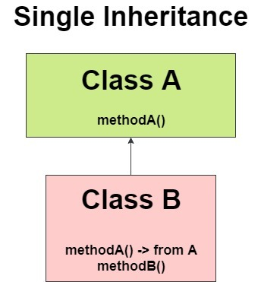

Eg: Inheritance_Demo_Eg1

5️⃣ Object Class – Very Important (Expanded)
Correct Points
- Object class is present in java.lang package
- It is the root class of Java
- Every class in Java:
  - Directly OR
  - Indirectly
inherits from Object
Common Object class methods:
- toString()
- equals()
- hashCode()
- getClass()
- clone()
- finalize()

6️⃣ Multilevel Inheritance
Concept
Multilevel inheritance in Java is a type of inheritance where a class is derived from another class that is also derived from another class, forming a chain of inheritance in which each subclass inherits the properties and methods of all its parent classes.

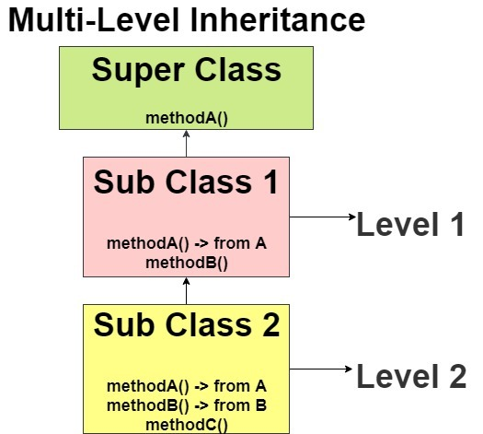

Eg: Multilevel_Inheritance_Eg2

7️⃣ Hierarchical Inheritance
Hierarchical inheritance in Java means one parent class is extended by multiple child classes.

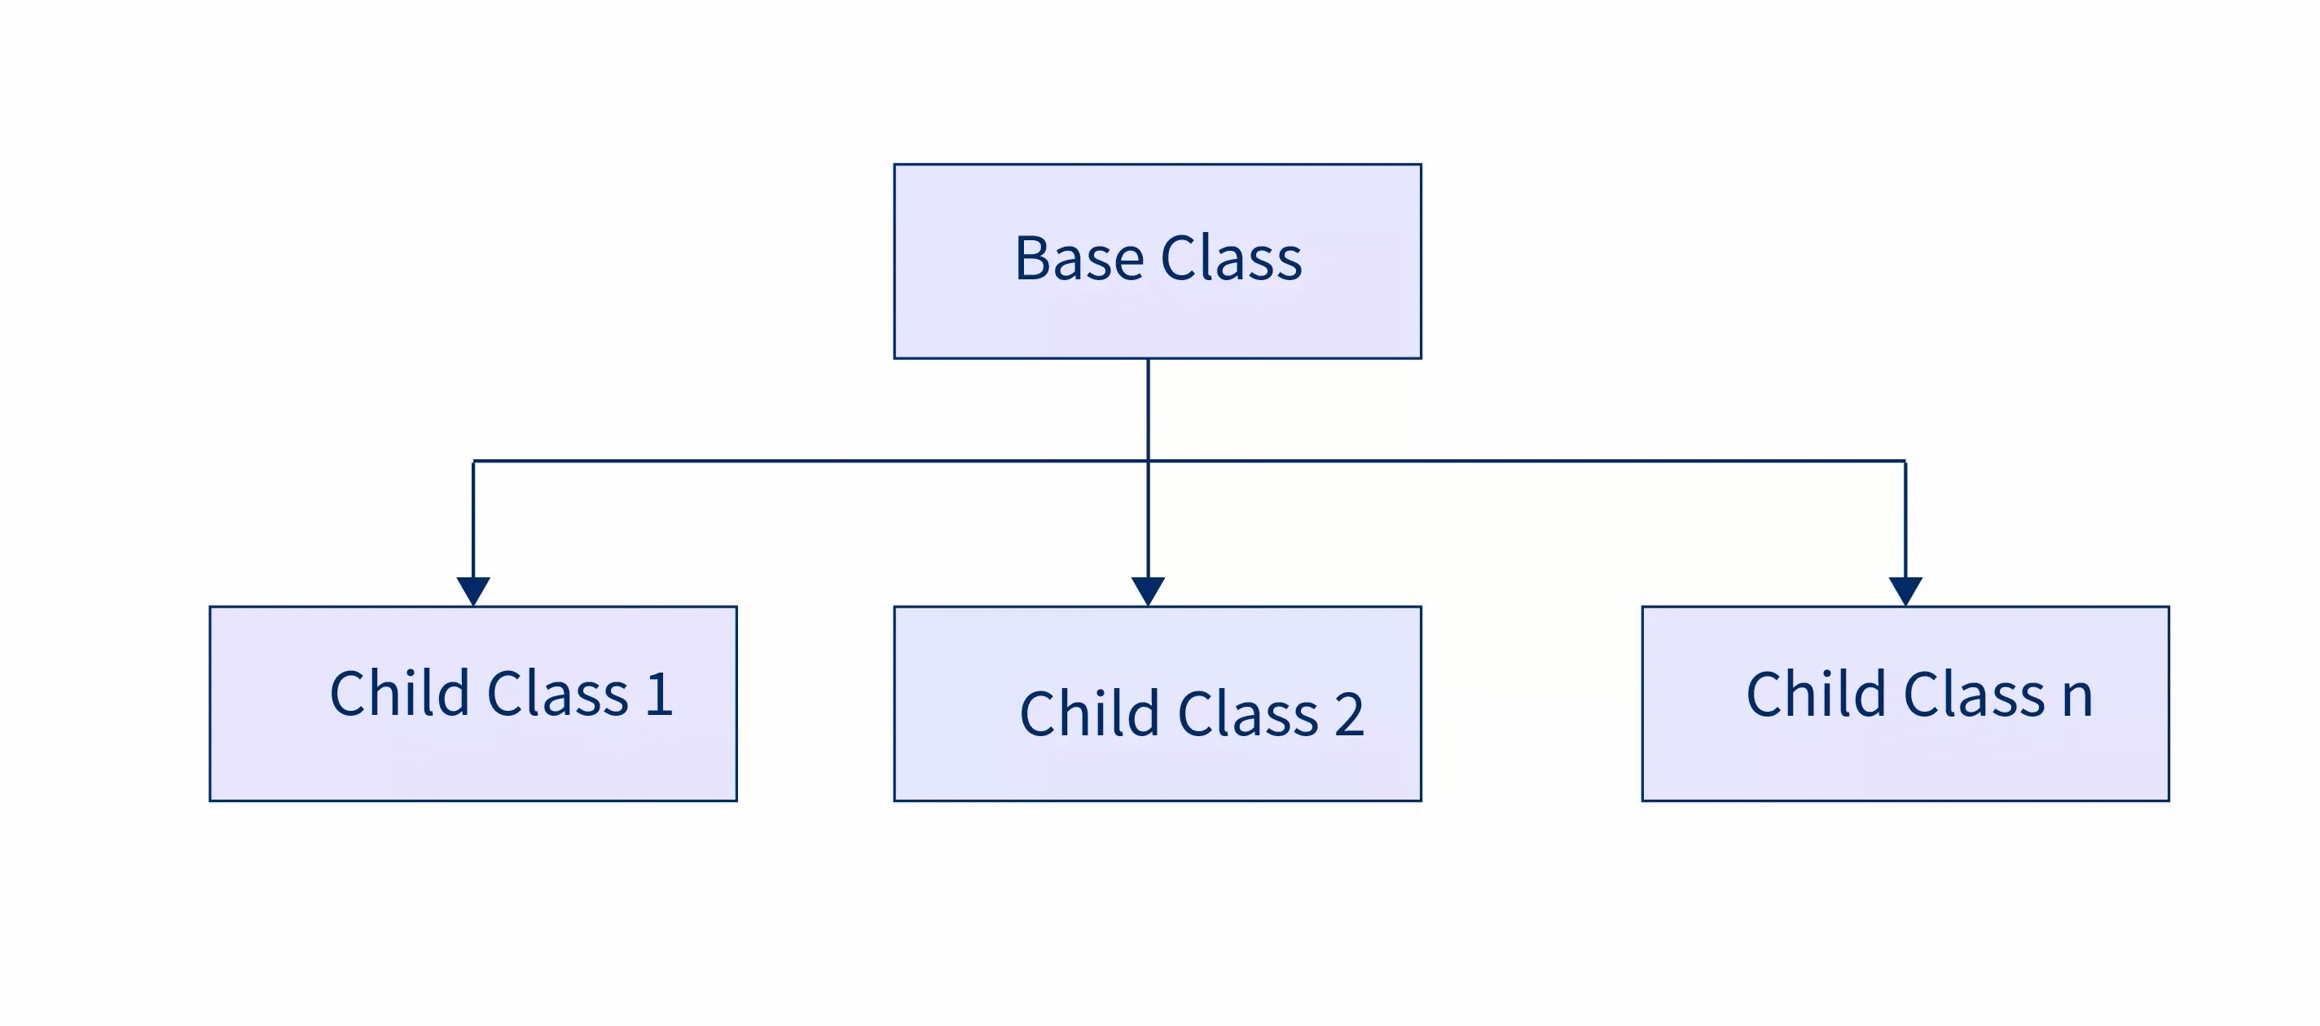
Eg: Hierarchical_Inheritance_Eg3

🔹 Definition of Hybrid Inheritance (Java-correct)
Hybrid inheritance is an inheritance structure that combines two or more types of inheritance (such as single, multilevel, or hierarchical) in a single design.
In Java:
- Hybrid inheritance is allowed with classes only when no multiple inheritance is involved.
- If hybrid inheritance requires multiple inheritance, it cannot be implemented using classes and must be implemented using interfaces.

📌 Clear Rule Table (No Confusion)
Hybrid Structure | Multiple Inheritance Present? | Allowed with Classes? | Allowed with Interfaces?
Single + Hierarchical | ❌ No | ✅ Yes | ✅ Yes
Multilevel + Hierarchical | ❌ No | ✅ Yes | ✅ Yes
Diamond-shaped hybrid | ✅ Yes | ❌ No | ✅ Yes
Any hybrid needing 2 parents | ✅ Yes | ❌ No | ✅ Yes

Different combinations of hybrid inheritance:

Java allows multiple inheritance ONLY when additional parents are interfaces.
Java never allows a class to have more than one class parent.
🟢 Case 1: 2 Classes → 1 Class (❌ NOT allowed)
class A { }
class B { }

class D extends A, B { } // ❌ NOT allowed
❌ Reason:
- Ambiguity
- Diamond problem
- JVM confusion
🚫 This is multiple inheritance using classes → Java forbids it

🟢 Case 2: 1 Class + 1 Interface → 1 Class (✅ Allowed)
class A { }

interface B { }

class D extends A implements B { } // ✅ Allowed
✔️ One class parent
✔️ One interface parent
✔️ Multiple inheritance achieved safely
👉 This is what your code is doing

🟢 Case 3: 1 Class + Multiple Interfaces → 1 Class (✅ Allowed)
class A { }

interface B { }
interface C { }

class D extends A implements B, C { } // ✅ Allowed
✔️ One class
✔️ Many interfaces
✔️ Very common in real projects (Spring, Java APIs)

🟢 Case 4: 2 or More Interfaces → 1 Class (✅ Allowed)
interface A { }
interface B { }

class D implements A, B { } // ✅ Allowed
✔️ No class parent
✔️ Only interfaces
✔️ Pure multiple inheritance

🟢 Case 5: Interfaces extending Interfaces (✅ Allowed)
interface A { }
interface B { }

interface C extends A, B { } // ✅ Allowed
✔️ Interfaces can extend multiple interfaces
✔️ This is multiple inheritance at interface level

🟢 Case 6: Class extending Interface (❌ NOT allowed)
interface A { }

class B extends A { } // ❌ NOT allowed
❌ Wrong keyword
❌ Classes use implements, not extends

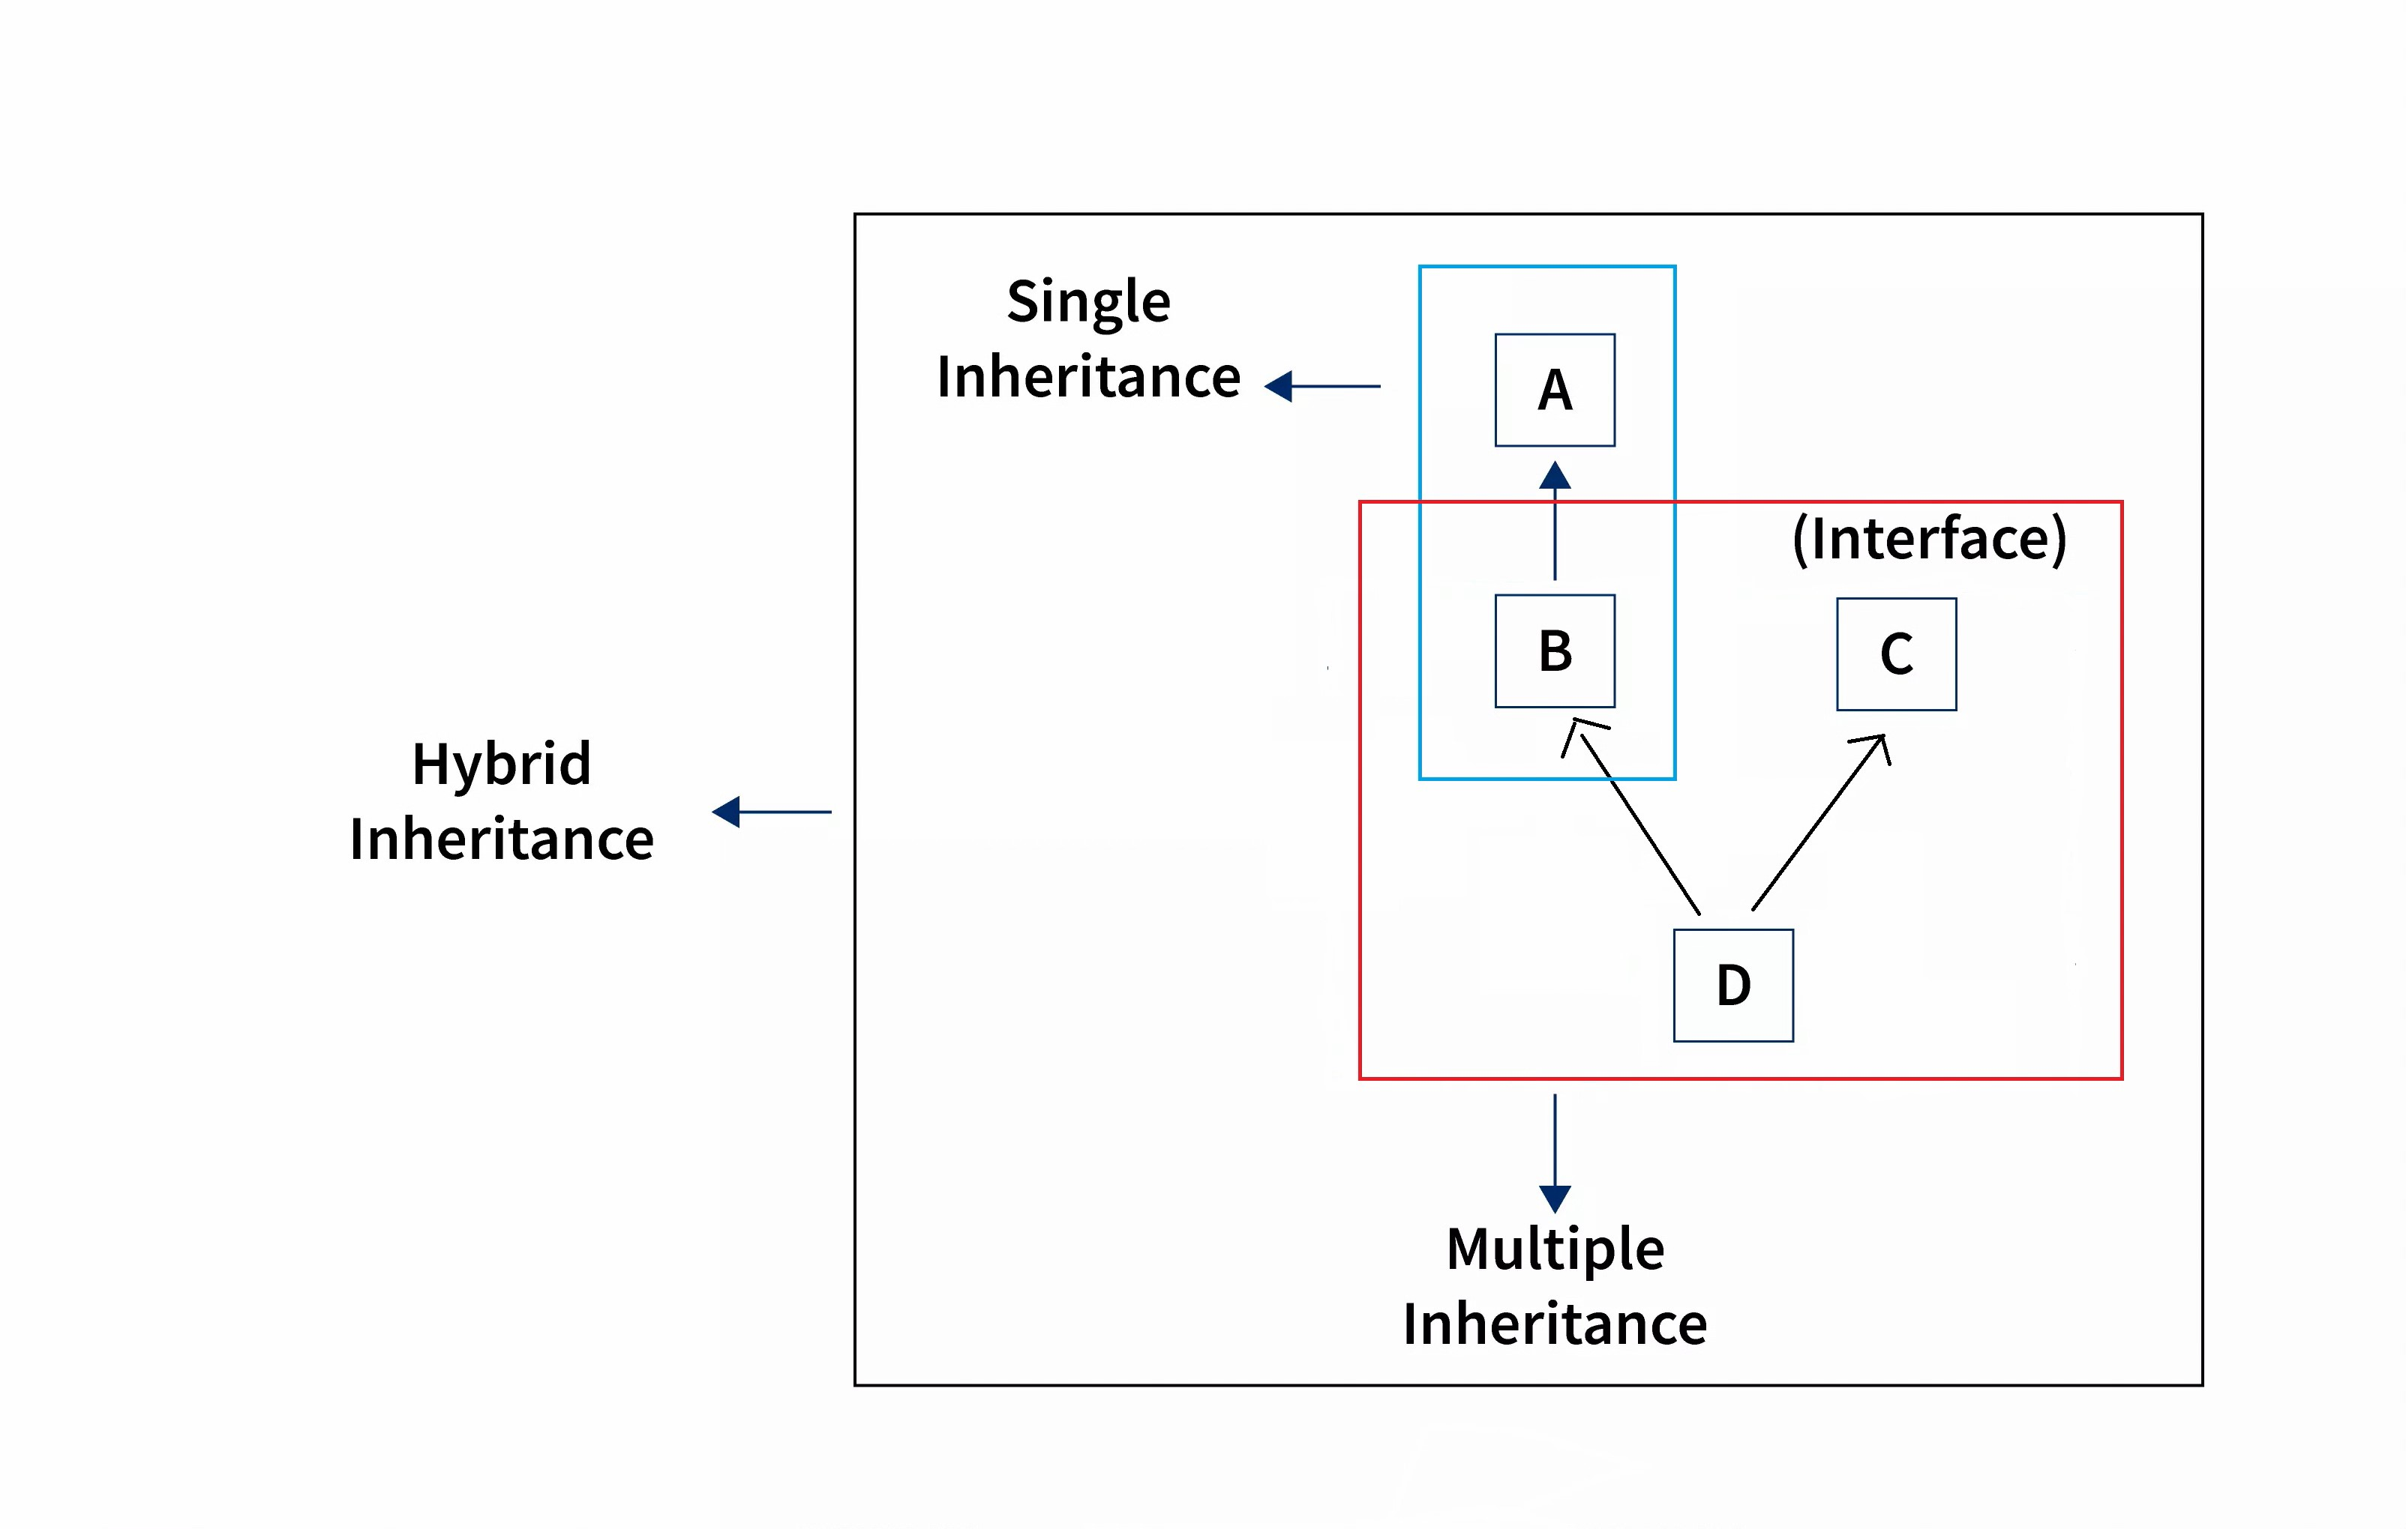
Eg : Hybrid_Inheritance_Eg1

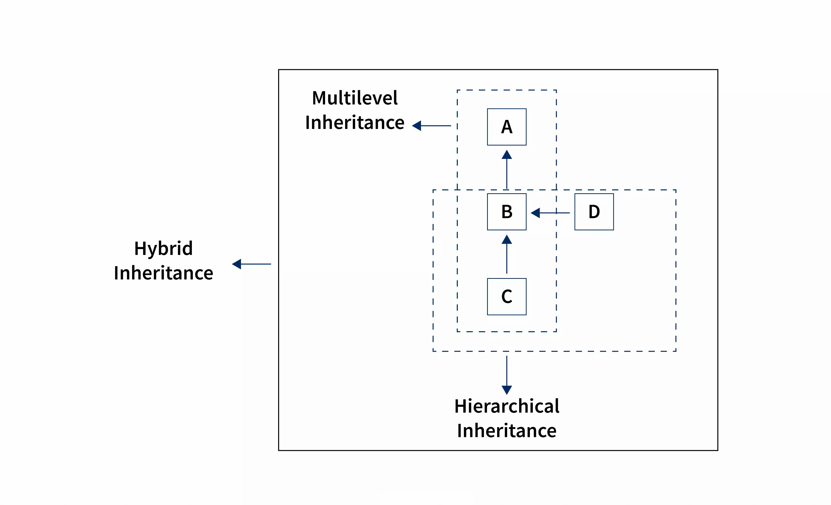
Eg: Hybrid_Inheritance_Eg2
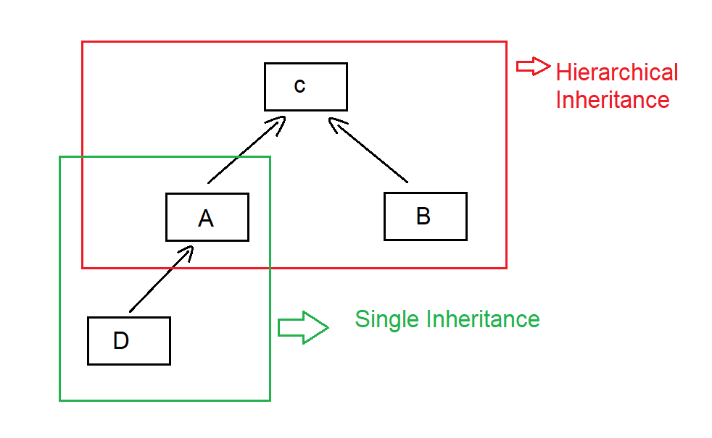
Eg: Hybrid_Inheritance_Eg3

Multiple inheritance using classes is not allowed in Java
What does multiple inheritance mean?
Multiple inheritance means:
One child class tries to extend more than one parent class
Example (❌ NOT allowed in Java):
class A {
void show() {
System.out.println("A");
}
}

class B {
void show() {
System.out.println("B");
}
}

// ❌ Java does NOT allow this
class C extends A, B {
}
Java completely blocks this syntax.

2️⃣ Reason: Ambiguity when two parent classes have the same method / variable
What is ambiguity?
Ambiguity means:
Java gets confused and cannot decide which parent’s member to use
Why does confusion happen?
Both parent classes contain the same method name:
class A {
void show() {
System.out.println("From A");
}
}

class B {
void show() {
System.out.println("From B");
}
}
Now assume Java allowed this:
class C extends A, B {
public static void main(String[] args) {
C obj = new C();
obj.show(); // ❓ Which show()?
}
}
🔴 Big Question for Java
- Should show() come from A?
- Or from B?
👉 Java cannot guess
👉 Java does not auto-pick
👉 Java forces clarity at compile time
This confusion is called ambiguity.

3️⃣ Diamond Shape Problem → Compile-time ambiguity
Now let’s see WHY it is called a Diamond Problem
Diamond-shaped inheritance diagram
A
/ \
B C
\ /
D
Code version (conceptual)
class A {
void display() {
System.out.println("A");
}
}

class B extends A {
}

class C extends A {
}

class D extends B, C { // ❌ Not allowed
}
What happens internally?
- B gets display() from A
- C gets display() from A
- Now D gets two paths to display()
A → B → D
A → C → D
🔴 Ambiguity at compile time
When D calls:
display();
Java asks:
Which path should I follow?
- Via B?
- Via C?
This confusion happens before the program runs, so it is a
👉 Compile-time ambiguity

7️⃣ Cyclic Inheritance in Java
Cyclic inheritance means:
- A class cannot be both parent and child of another class (directly or indirectly)
❌ Invalid
class A extends B {}
class B extends A {}
This causes an infinite inheritance loop, so Java blocks it at compile time.
✔️ Java compiler detects this early
✔️ This rule prevents infinite memory dependency

